Kunsthistorisches Museum

Ahmad Hasan Ahmad

2023-04-27

Table of contents

# 1. Kunsthistorisches Museum

Author: Ahmad Hasan Ahmad

ORCID: https://orcid.org/0009-0008-4964-222X

Date: 28.04.2023

DOI: 10.5281/zenodo.7873444

Repository URL: https://github.com/Ahmad19111/catalogue-003

## 1.1 Based on Baroque AI: Publication Prototype

## 1.2 Part of the series: Baroque TOC

[Programme instructions](https://nfdi4culture.github.io/class-ADA-CP-pipeline/)

2023-03-17

This work is licensed under a Creative Commons Attribution-ShareAlike 4.0 International License.

Book cover: Reworking of [Baroque pearl with enamelled gold mounts set with rubies](https://en.wikipedia.org/wiki/File:Pendant_in_the_form_of_a_siren_MET_DT7173.jpg). Creative Commons CC0 1.0 Universal Public Domain Dedication. This file was donated to Wikimedia Commons as part of a project by the Metropolitan Museum of Art.

This work is licensed under a Creative Commons Attribution-ShareAlike 4.0 International License.

# 2. Colophon

* Fork title: Ahmad19111/catalogue-003
* Author: Ahmad Hasan Ahmad
* ORCID: https://orcid.org/0009-0008-4964-222X
* Date: 28.04.2023
* DOI: 10.5281/zenodo.7873444
* Repositor: https://github.com/Ahmad19111/catalogue-003

PUBLISHING FROM COLLECTIONS USES OF COMPUTATIONAL PUBLISHIGN AND LINKEDOPEN DATA

Open Science Lab - TIB Hannnover

First published 2023-03-30

Copyright © The Authors 2023 Licensed as https://creativecommons.org/licenses/by-sa/4.0/

DOI: https://doi.org/10.5281/zenodo.7701161

# 3. About the Museum

Source: https://de.wikipedia.org/wiki/Kunsthistorisches_Museum_Wien

### 3.0.1 Kunsthistorisches Museum

The Kunsthistorisches Museum (lit. “Museum of Art History”, often referred to as the “Museum of Fine Arts”) is an art museum in Vienna, Austria. Housed in its festive palatial building on the Vienna Ring Road, it is crowned with an octagonal dome. The term Kunsthistorisches Museum applies to both the institution and the main building. It is the largest art museum in the country and one of the most important museums worldwide.

Emperor Franz Joseph I of Austria-Hungary opened the facility around 1891 at the same time as the Natural History Museum, Vienna which has a similar design and is directly across Maria-Theresien-Platz.The two buildings were constructed between 1871 and 1891 according to plans by Gottfried Semper and Baron Karl von Hasenauer. The emperor commissioned the two Ringstraße museums to create a suitable home for the Habsburgs’ formidable art collection and to make it accessible to the general public. The buildings are rectangular, with symmetrical Renaissance Revival façades of sandstone lined with large arched windows on the main levels and topped with an octagonal dome 60 metres (200 ft) high. The interiors of the museums are lavishly decorated with marble, stucco ornamentation, gold-leaf, and murals. The grand stairway features paintings by Gustav Klimt, Ernst Klimt, Franz Matsch, Hans Makart and Mihály Munkácsy.

# 4. Activity: Paintings catalogue

Wikidata link: <http://www.wikidata.org/entity/Q27978030>

Title: Q27978030

Year: 1680

Creator: http://www.wikidata.org/.well-known/genid/e1a1d42edd6898f08870940f93af92bb

Copyright: public domain

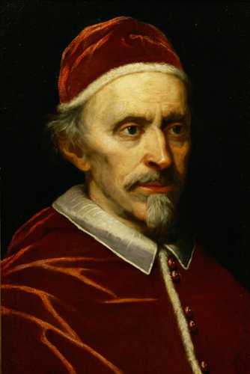

Wikidata link: <http://www.wikidata.org/entity/Q27978034>

Title: Portrait of Francesco Donato, Doge of Venice

Year: 1550

Creator: http://www.wikidata.org/.well-known/genid/c11b26a08ab822f4ac67111d6a1c347d

Copyright: public domain

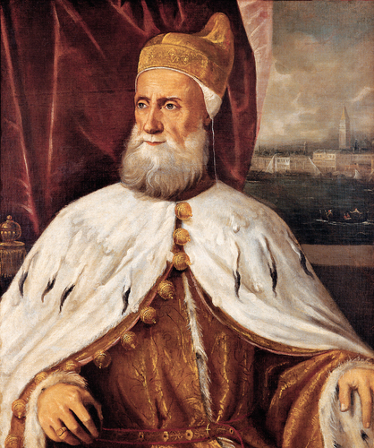

Wikidata link: <http://www.wikidata.org/entity/Q27978038>

Title: Portrait of Niccolo da Ponte (1491-1585), Doge of Venice

Year: 1580

Creator: Palma il Giovane

Copyright: public domain

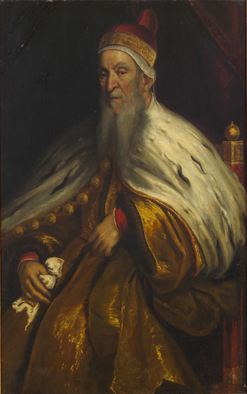

Wikidata link: <http://www.wikidata.org/entity/Q27978039>

Title: Q27978039

Year: 1570

Creator: http://www.wikidata.org/.well-known/genid/978a9fa5439228d315e593fef98918f4

Copyright: public domain

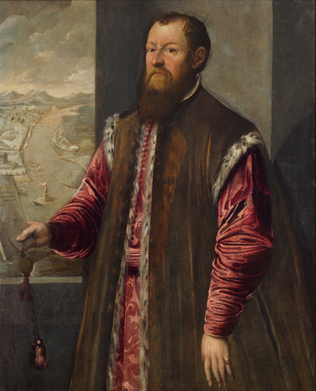

Wikidata link: <http://www.wikidata.org/entity/Q27978043>

Title: Portrait of Grand Duchess Bianca Capello (1548-1587)

Year: 1584

Creator: Scipione Pulzone

Copyright: public domain

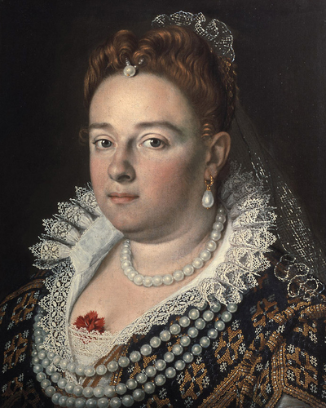

Wikidata link: <http://www.wikidata.org/entity/Q27978048>

Title: Portrait of Vicenzo I. Gonzaga, Duke of Mantua

Year: 1600

Creator: Frans Pourbus the Younger

Copyright: public domain

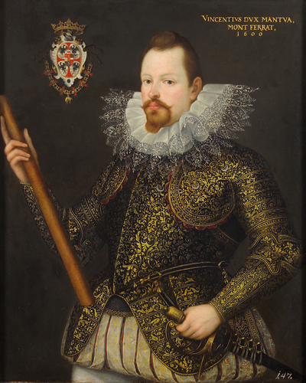

Wikidata link: <http://www.wikidata.org/entity/Q27978051>

Title: Q27978051

Year: 1600

Creator: http://www.wikidata.org/.well-known/genid/ca000ef5d74f8c9aafa72037332af757

Copyright: public domain

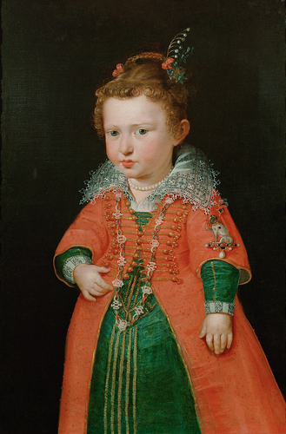

Wikidata link: <http://www.wikidata.org/entity/Q27978051>

Title: Q27978051

Year: 1600

Creator: http://www.wikidata.org/.well-known/genid/ca000ef5d74f8c9aafa72037332af757

Copyright: public domain

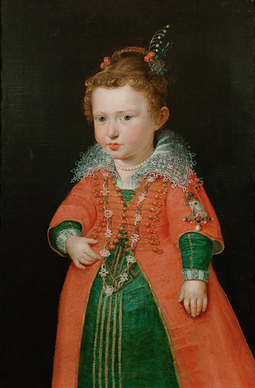

Wikidata link: <http://www.wikidata.org/entity/Q27978054>

Title: Portrait of Eleonore von Gonzaga (1598-1655), wife of Ferdinand II

Year: 1621

Creator: Justus Sustermans

Copyright: public domain

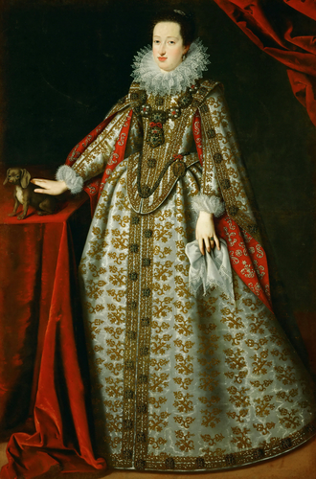

Wikidata link: <http://www.wikidata.org/entity/Q27978054>

Title: Portrait of Eleonore von Gonzaga (1598-1655), wife of Ferdinand II

Year: 1621

Creator: Justus Sustermans

Copyright: public domain

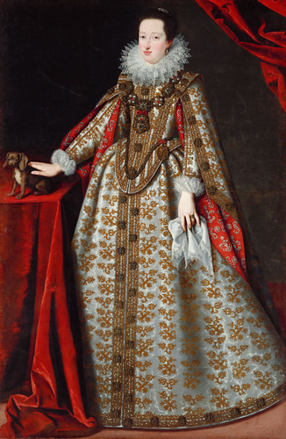

Wikidata link: <http://www.wikidata.org/entity/Q27978055>

Title: Portrait of Eleonore von Gonzaga (1598-1655), Empress in Black Dress

Year: 1623

Creator: Justus Sustermans

Copyright: public domain

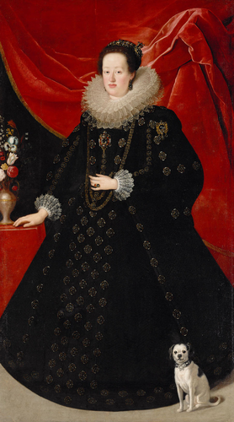

Wikidata link: <http://www.wikidata.org/entity/Q27978056>

Title: Portrait of Eleonora of Gonzaga-Nevers (1639-1686)

Year: 1651

Creator: Frans Luycx

Copyright: public domain

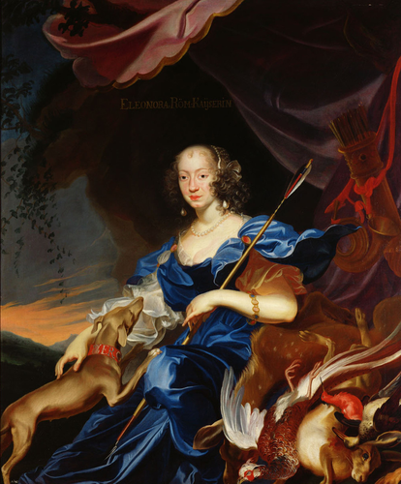

Wikidata link: <http://www.wikidata.org/entity/Q27978058>

Title: Portrait of I de’ Medici

Year: 1560

Creator: http://www.wikidata.org/.well-known/genid/609c2e55a3e1deab200782a4d5806d4b

Copyright: public domain

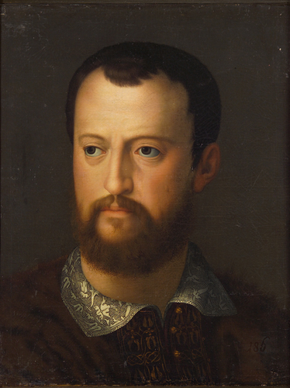

Wikidata link: <http://www.wikidata.org/entity/Q27978061>

Title: Q27978061

Year: 1565

Creator: Giovanni Bizzelli

Copyright: public domain

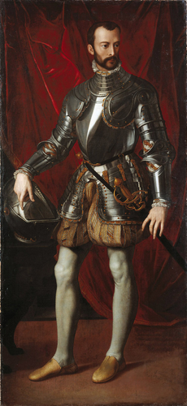

Wikidata link: <http://www.wikidata.org/entity/Q27978062>

Title: Q27978062

Year: 1550

Creator: Scipione Pulzone

Copyright: public domain

